CALM Act Certification

This is to certify that:

- As required by Sections 73.682(e) and 76.607(a) of Title 47 of the Code of Federal Regulations, all commercial advertisements embedded in programs carried on TCT (SD1) are or will be in compliance with the loudness control practices contained in Advanced Television Systems Committee (ATSC) A/85: Recommended Practice: Techniques for Establishing and Maintaining Audio Loudness for Digital Television (“ATSC A/85 Recommended Practice”) at the point of distribution by TCT Ministries, Inc. to authorized reception equipment of television broadcast station viewers and downstream multichannel video programming distributors.

- Compliance with the ATSC A/85 Recommended Practice by TCT (SD1) is determined through the use of equipment and associated software that is installed, utilized and maintained in a commercially reasonable manner.

Executed this 3rd day of January 2023.

By: 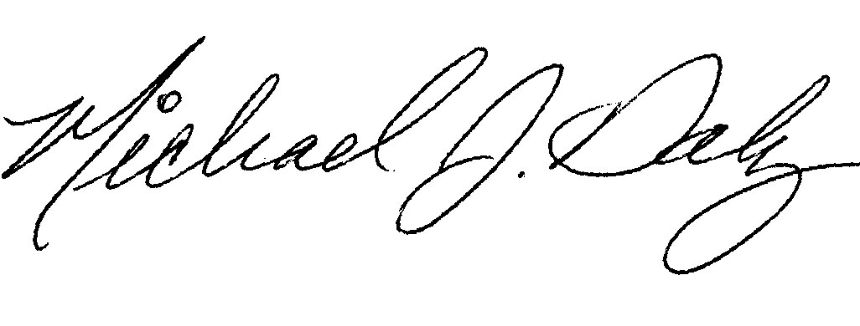
Michael Daly, Secretary

