CALM Act Certification

This is to certify that:

- As required by Sections 73.682(e) and 76.607(a) of Title 47 of the Code of Federal Regulations, all commercial advertisements embedded in programs carried on TCT-HD (HD) are or will be in compliance with the loudness control practices contained in Advanced Television Systems Committee (ATSC) A/85: Recommended Practice: Techniques for Establishing and Maintaining Audio Loudness for Digital Television (“ATSC A/85 Recommended Practice”) at the point of distribution by TCT Ministries, Inc. to authorized reception equipment of television broadcast station viewers and downstream multichannel video programming distributors.

- Compliance with the ATSC A/85 Recommended Practice by TCT-HD (HD) is determined through the use of equipment and associated software that is installed, utilized and maintained in a commercially reasonable manner.

Executed this 3rd day of January 2023.

By: 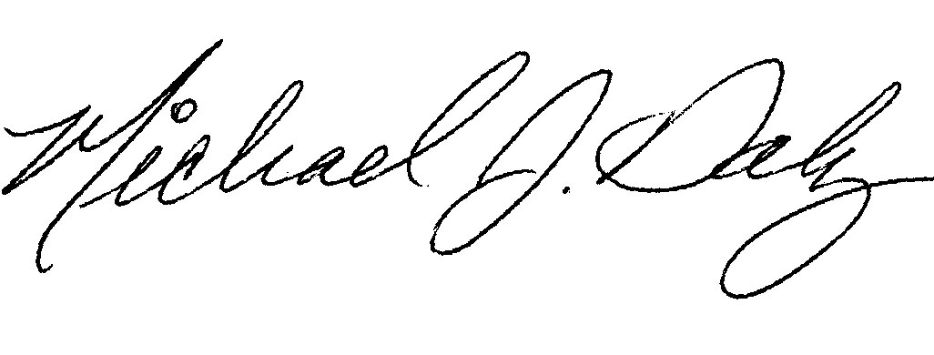
Michael Daly, Secretary

